1. 
2. Geodesy in Iceland
3. *Work in the DRF-Iceland pre-project*

|  |
| --- |
| Delivery description: |

|  |  |  |  |
| --- | --- | --- | --- |
| Version: 1.0 | Last change:  201x-xx-xx | Authors:  Guðmundur Valsson | Accepted by:  DRF-Iceland team |

Geodetic perspectives in Iceland

The National Geodetic Network of Iceland was measured for the third time in 2016. The network was measured for the first time in 1993 and then again in 2004. The datums ISN93 (ITRF epoch 1993.6) and ISN2004(IGb00 epoch 2004.6, with absolute PCV antenna models) were static, meaning that the coordinates of the network benchmarks are kept frozen at their epoch. Having a static datum in Iceland is problematic when it comes to precise surveying. Iceland is situated on the boundaries of the Eurasian and North-American tectonic plates. The plates are drifting apart with a rate of aprox. 1cm/year from each other. The plate boundaries interact with a deep-seated mantle plume currently situated under Vatnajökull. This leads to complicated pattern of rift and transform fault zones. This means that the network is constantly deforming due to plate tectonics. Earthquakes and volcanic eruptions and melting of the Icelandic glaciers do also have a serious impact on the network. Sometimes very locally, but also over lager areas.

### The ISNET2016 campaign and ISN2016

The ISNET2016 campaign started in April and ended in September. The country was divided into 13 survey blocks. Overall 134 benchmarks and pillars were measured usually for 90-100 hours each. In addition, data from 106 CORS stations was collected.

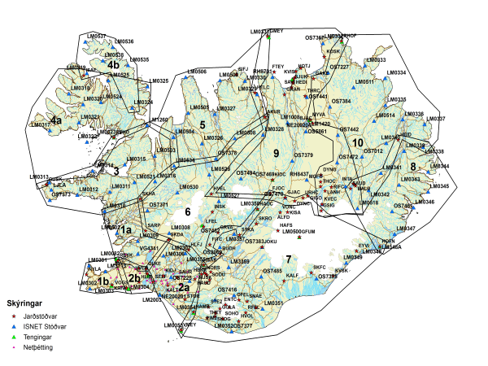

Figure 1. The ISNET2016 survey plan.

The data processing can be divided into two parts. Defining a local reference frame and processing the campaign data. For the local reference frame, we processed 6 mounts of data from 24 CORS + 2 campaign stations in Northwest Iceland. To connect to a global reference, we used 7 IGS stations. The processing was done in Bernese 5.2 per NKG AC settings. The processing was first done in IGb08 and then later in ISG14 when it became available. Final adjustment was done with ADNEQ2 with minimal constrains, reference epoch 2016.5.

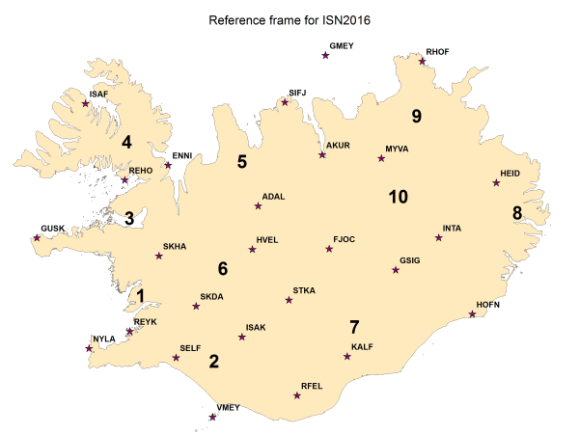

Figure 2. Local reference frame for ISN2016

Each campaign was then processed wit the NKG AC setting with the new local reference frame. Bad data was thrown out. And final adjustment performed with ADNEQ2 with all campaigns combined. Constrained solution with 1mm a priori sigma gave the best RMS, but numerically it was the same result as for minimal constrained solution, down to fraction of mm.

### Deformation from 1993 to 2016

It’s interesting to compare the three campaigns to see deformation of the geodetic network. This isn’t trivial though since the campaigns are not all processed in the same reference frame. We have processed 8 core stations of the ISNET2004 campaign and there seems to be a systematic difference of 4mm for the north component. We also did some analysis of the ISN93 when we did comparison with ISN2004 and found out that main difference between ITRF93 and IGb00 is a scale factor of about 11 ppb causing about 7 cm systematic vertical difference between ISN93 and ISN2004. The main reason for this is a difference in use of PCV models. When we have corrected for this we can start to compare the campaigns and estimate the deformation of the geodetic network. ISN93 is still widely used in so it’s important to look closely at the deformation since 1993

First we look at the total horizontal coordinate change between 1993 and 2016

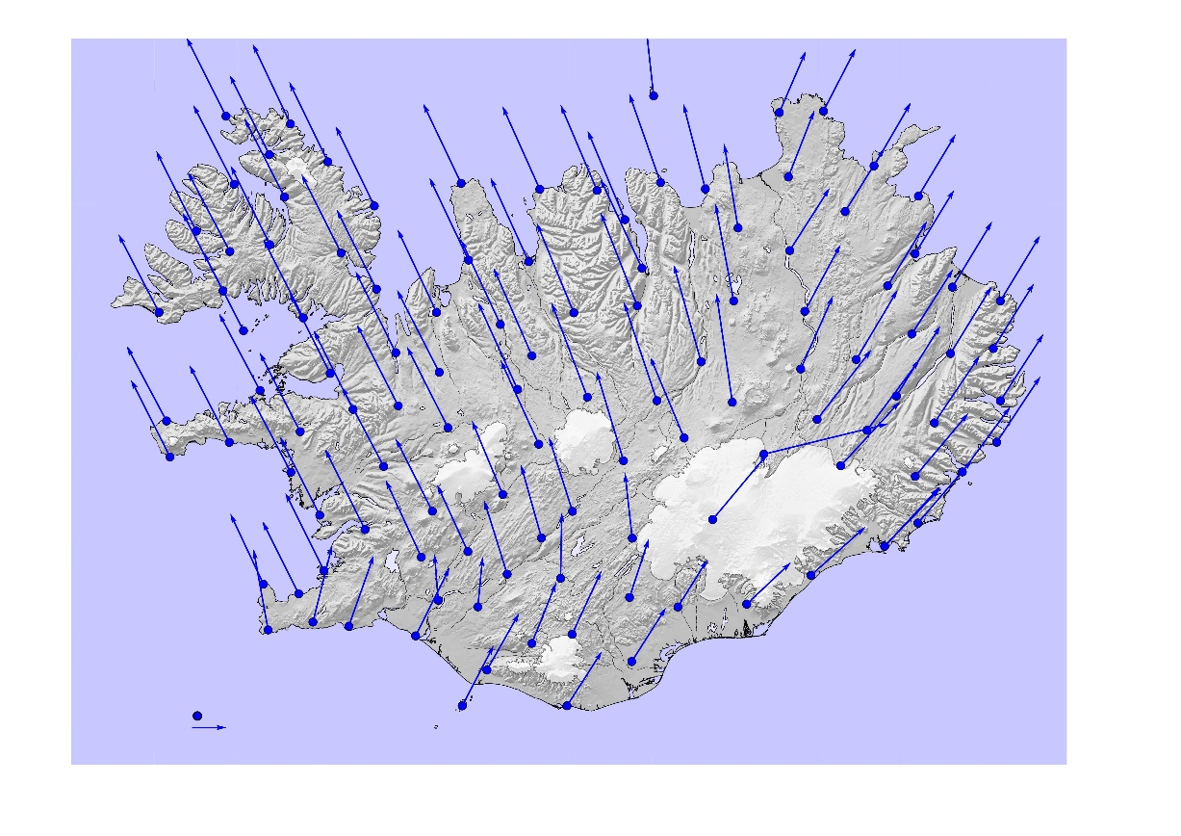

Figure 3. Horizontal movement between 1993 and 2004.

We can see the common northward movement. The average northward movement is 0.433m, ranging from 0.180 to 0.642m over a period of 23 years. We can also see how the country is drifting apart. The maximum value is in Kverkfjöll, north of Vatnajökull, 0.733m and the minimum is -0,249. So, there we almost 1m relative difference in the network. The common northward component is very domination so we usually remove the average northward movement to analyze the deformation. Let’s now look at the difference between ISN93 and ISN2004 after we removed the north component.

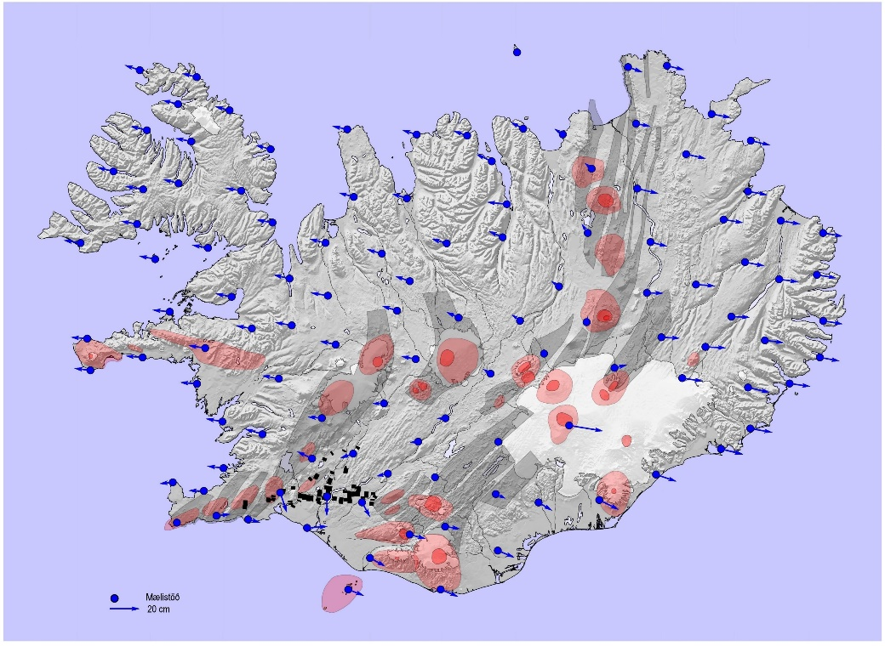

Figure 4. Horizontal deformation between 1993 and 2004.

We can see clearly how Iceland is drifting apart and how the vectors gets smaller when we get closer to the plate boundaries. We can also see that the northward movement is slightly higher on the North-America plate compared to the Eurasian plate. We also see the effect of the earthquakes in June 2000 in southwestern part of Iceland and some effect from volcanic eruption in Grímsvötn.

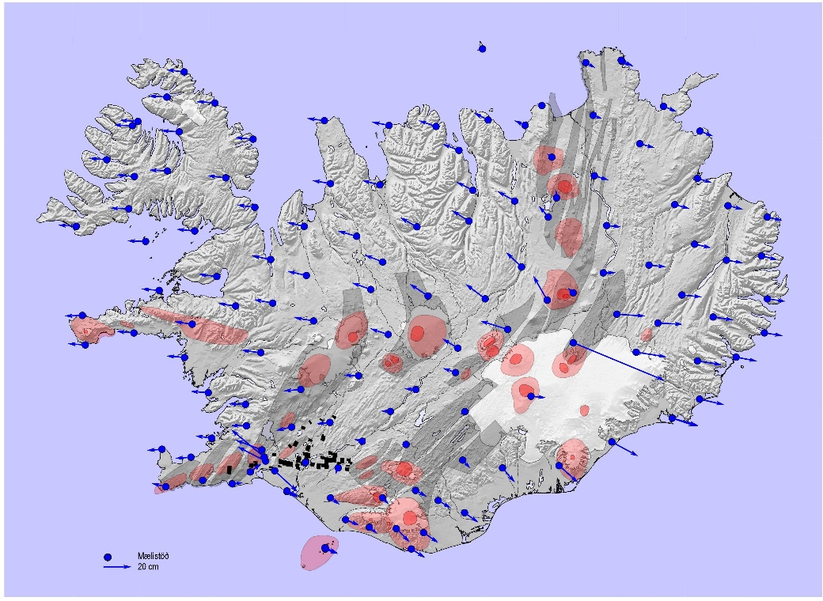

Figure 5. Horizontal deformation between 2004 and 2016.

If we look at the changes from 2004 to 2016 it looks similar in many ways but there are clearer signals from geophysical events in this period. The deformation in southwestern Iceland is from the earthquake in May 2008 causing more the 0.45cm deformation between the town of Hveragerði and Selfoss. The distance between the towns is 15km. The effect of the eruption in Holuhraun, north of Vatnajökull, is also very clear. Not only in Kverkfjöll where the eastward movement was 0.654m compared to 0.079 between 1993 and 2004. But in all the surrounding points. Jumps are visible in time series up to more than 150 km from the eruption. We can also see that the northward component south and southwest of Vatnajökull is smaller compared to other areas on the Eurasian plate. This might be an effect from a land uplift. So, the next step is to look at vertical changes. Let’s first observe changes between 1993 to 2004. We observed land uplift up to 20.1 cm and land subsidence of -12.2 cm. This comparison revealed for the first time the land uplift over such a large area in the center of Iceland. Before that time observed land uplift in certain benchmarks was believed to something more local. The cause for the land uplift considered to be the current melting of the glaciers in Iceland. The land subsidence in the southwestern tip of the Reykjnes peninsula is caused by a geothermal power plant located nearby. There has been some indication from time series from cGNSS stations in central Iceland that the we have some acceleration in the land uplift after 2004. Therefore, it’s very interesting to look at the vertical changes between 2004 and 2016. It’s clear that we have a significant increase in the land uplift in central Iceland and along the southeastern coast. The maximum uplift now is 39.1 cm and the maximum subsidence -19.5 cm. It’s very interesting to look at the area south of Vatnajökull where the observed land uplift was around 10 cm between 1993 and 2004, but around 30 cm between 2004-2016. There seems to be a slight increase in the land subsidence at the Reykjanes peninsula and we can also see an effect from a new geothermal power plant in Hellisheiði, east of Reykjavík.

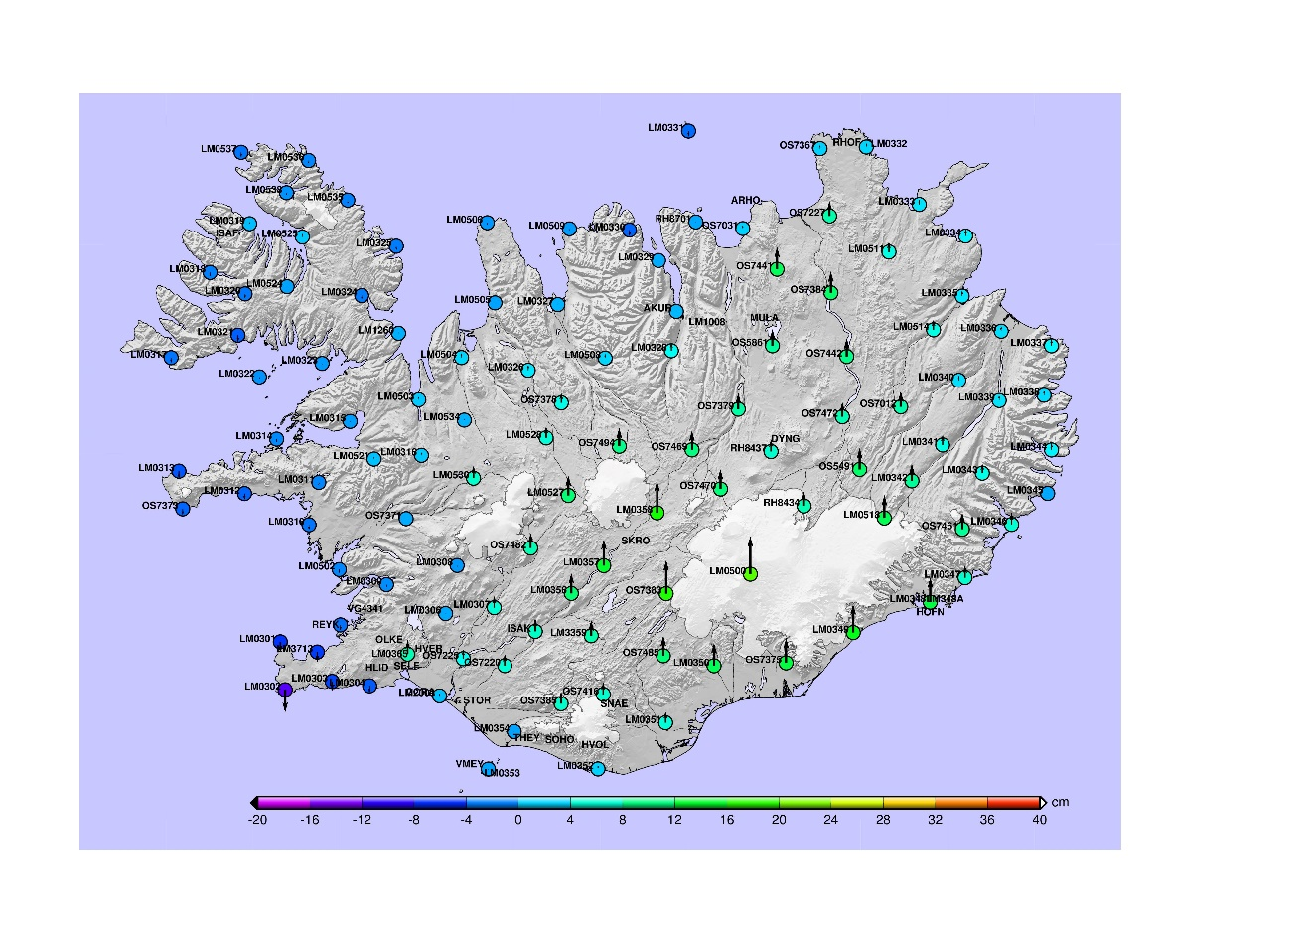

Figure 6. Land uplift between 1993 and 2004

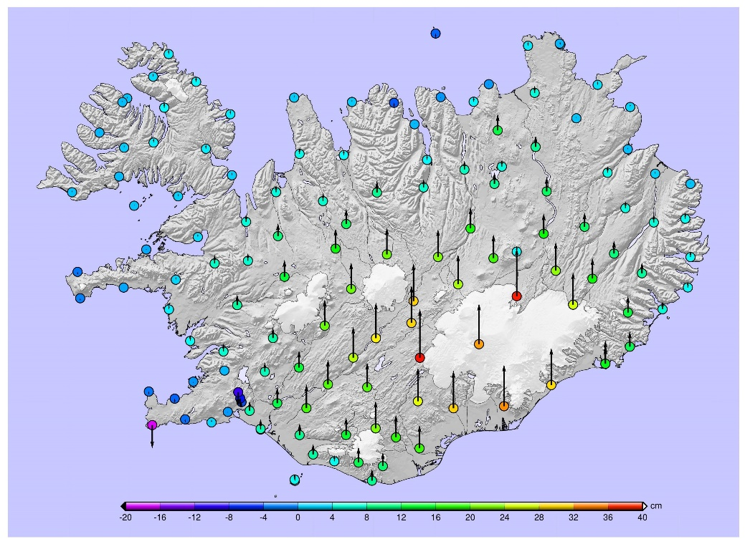

Figure 7. Land uplift between 2004 and 2016

From this overview, we can clearly see the challenge in having a precise geodetic datum in Iceland. The ISN93 datum is still widely used in Iceland. Some user’s claim that they are working in rater small areas so they should not be effected by the deformation of the network. This means that those users believe that the relative accuracy is still acceptable and it will not affect their results. We have been analyzing relative accuracy of ISN93 plotted a map showing the effect of the horizontal deformation in terms of ppm. The magenta and purple areas have relative deformation less than 0.5ppm. The dark blue to light blue areas are between 0.5 and 2ppm. Other color represents more deformation as we can see in figure 8. Modern RTK survey equipment has an accuracy of 5-10mm+0.5-1 ppm. The deformation will affect results of a RTK survey for more than half of Iceland, and therefore making it dependent on which base station was used for the survey.

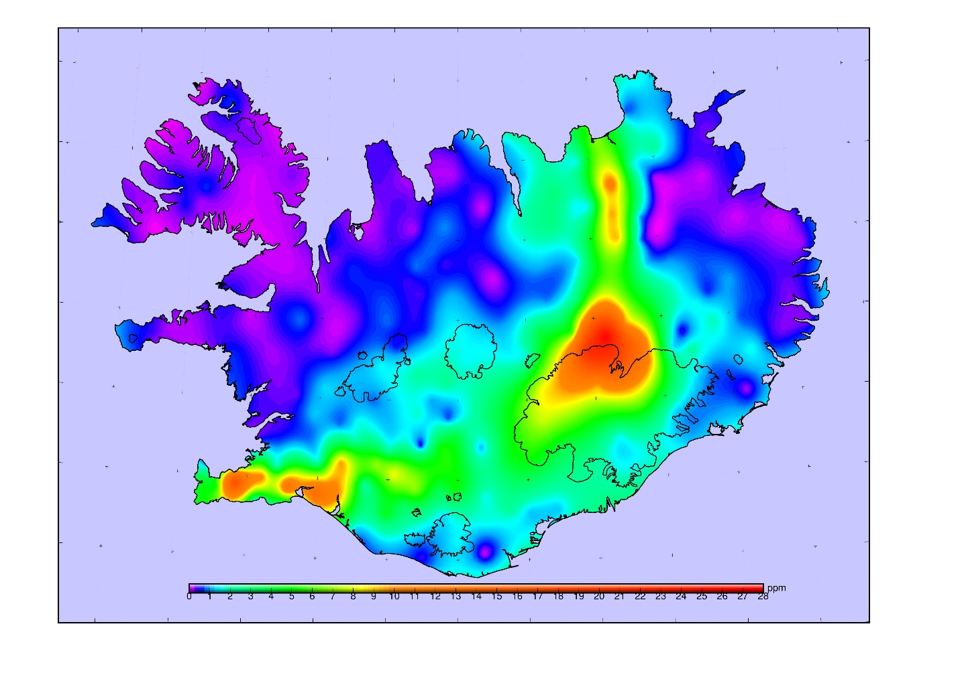

Figure 8. Relative deformation of ISN93 in 2016 in therms of ppm

It is also impossible to operate a network RTK system for Iceland if we keep the station coordinates fixed we don’t get fixed solution for the network after few years because of the deformation.

Therefore, it’s impossible to maintain a modern precise geodetic datum in Iceland without taking the deformation into account.

### Modeling the deformation

We can divide the geophysical processes causing the deformation of the geodetic network into two categories. Long term processes like plate tectonics, land uplift and land subsidence and periodic processes like earthquakes and volcanic eruptions. To model the long term processes a velocity model based on data from cGNSS stations is a very suitable method. There are over 100 cGNSS stations in Iceland, most of the owned by the geophysical community. But they are not evenly distributed. Most of them are in active areas, see figure 9. To get more density for our velocity model we must also use data from repeated eGNSS campaigns, like the ISNET campaigns. When using eGNSS data for velocity modeling it’s vital that all the data is in the same reference frame. It might be vise to establish a local realization of a global reference frame. NLSI is a part of the NKG analysis center and data from 16 cGNSS has been reprocessed for the period 2001-2016. After time series analysis, we can choose the most stable ones as reference sites for the local realization. Then we can process data from other cGNSS and eGNSS stations to get more velocities for the long-term velocity model.

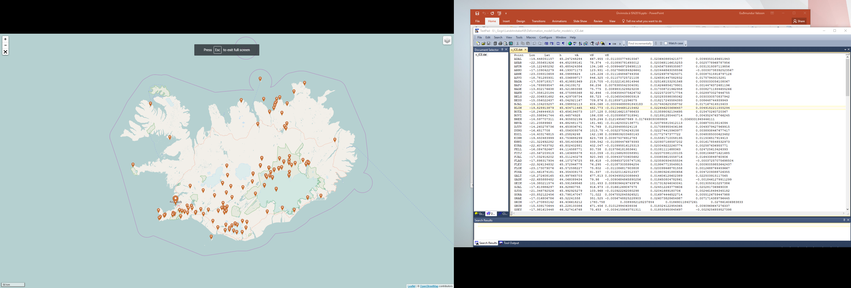

Figure 9. cGNSS stations in Iceland

There are several methods that can be used to make the model. E.g. LCC, Kriging, Minimum Curvature. We must investigate what is the most suitable method. This depends a little bit on the geometry of the velocity data. It’s quite hard to get a good network geometry in the rural areas of Iceland.

In the event of an earthquake or eruption we must investigate how much influence it has on the reference system. cGNSS are a very good indicator. Therefore there is much denser network of cGNSS and eGNSS stations in the active areas of Iceland. After an event, we should measure the network in effected area and model the deformation caused by the event. This is then applied as patch to the long-term model.

INSAR data might also be used for this purpose but we have to ensure that the model from the INSAR data is in the correct reference frame. Some fusion cGNSS, eGNSS and INSAR might be the best way to model periodic events. For this purpose, we might have to set up system of reflectors in the active areas of Iceland and investigate how we get the INSAR data into a correct reference.

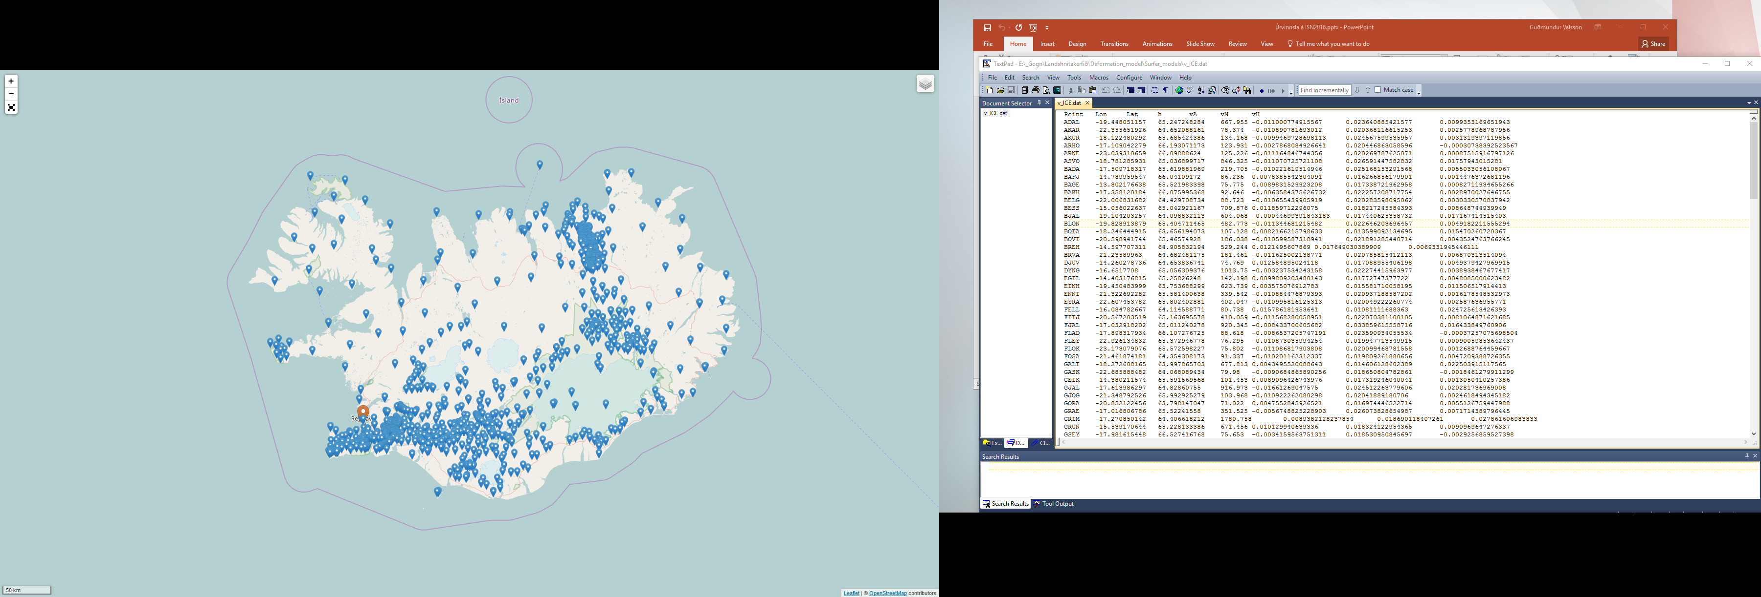

Figure 10. eGNSS stations in Iceland with repeated long GNSS observations

### IceCORS network RTK system of Iceland.

IceCORS is the network RTK system of Iceland. Currently we have 18 stations in our network (green on figure 11). The stations are owned by the National Land Survey of Iceland or by the Icelandic Met Office. The current goal is to have 31 stations in the system. Six stations owned by the Met Office (yellow) are already up running but we need establish real time data stream. Then we plan to build 7 new station. The equipment on the stations is very various. From modern GNSS receivers down to old GPS only receivers. The system is operated with GNSMART and the correction data is free of charge. The network is running on a best effort basis. That is if something breaks down NLSI or the IMO tries to fix it as soon as possible.

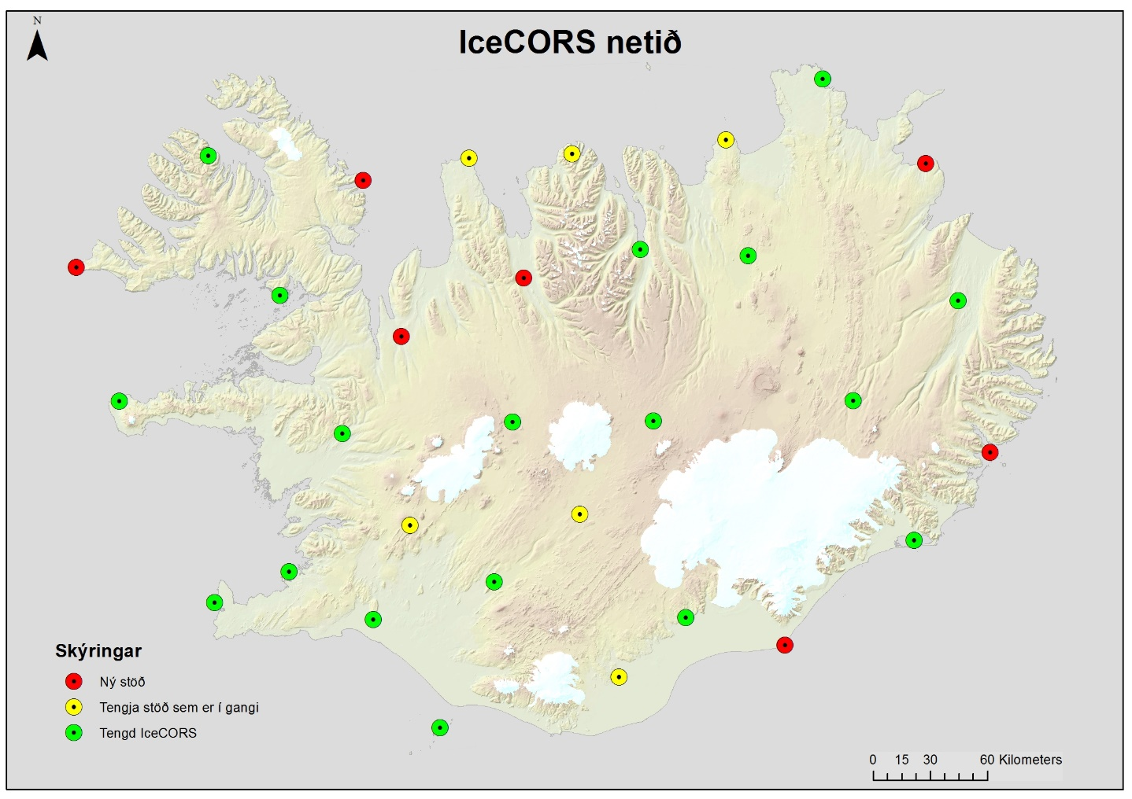

Figure 11. The IceCORS network

### Realization of a new semi-dynamic datum for Iceland ISN2016

To realize a new semi-dynamic datum for Iceland we must publish coordinates of our reference stations and benchmarks at the reference epoch and a velocity/deformation model to backdate all data to the reference epoch. We also have to make transformations to ISN2016 from ISN2004 and ISN93. The transformations are grid based in NTV2 format for X and Y and in GTX format for the change in height. The grids are computed in a similar manner as the velocity model. We also have to publish a new regulation for the new datum and apply for EPSG codes. Good cooperation with municipalities, institutions and private companies is vital.

The main issue is how to deal with the time factor. This is not possible in most surveying and GIS software today. But it might be included in near future versions of PROJ4. Otherwise we must develop our own methods. In our IceCORS system it’s possible to broadcast time dependent corrections through RTCM 3.X. There we will update the coordinates of our reference stations on a regular basis through the solutions from the NKG AC and use a deformation model to backdate the data to the reference epoch of ISN2016.

Further we have to develop new coco tools with time dependent functions and solve the issue of connecting the vertical reference system to ISN2016 thorough the geoid since it doesn’t have the same reference epoch.

Finally, we must make a maintenance plan for the network and update the velocity/deformation model on a regular basis.

### Realization of the dynamic reference frame

Realization of a dynamic reference frame is rather similar as the semi-dynamic datum. We will always need a velocity/deformation model to transform geodata to the current epoch. So, we have to find a way to deal with the time dimension. The operation of the IceCORS system is simpler since we don’t have to broadcast any corrections only update the coordinates of the reference stations regularly. But there are some differences. Fully dynamic systems would only be based on cGNSS sations, so we will need more cGNSS stations in Iceland to ensure total coverage with acceptable accuracy. There would also be an additional cost in running the Network RTK system since the reliability of the system must be improved compared how it is today and all equipment must be modernized. We also must constantly update the coordinates of all survey benchmarks, since not all survey techniques are satellite based and also to make quality check of RTK-GNSS surveys possible.

### Modernized Geodetic Information System

There is a work going on to modernize the Geodetic Information System in Iceland at the NLSI. Today information’s about benchmarks are usually in some survey reports and there are some available through web services.

The plan is to make a modern database so the users can access all information about a survey benchmark or a cGNSS station at the same place. The database will be divided into three parts. Station info, where we have all information about the physical benchmark or the cGNSS station. Coordinate info where we have all the information’s about coordinates, heights and gravity. Here we also must consider the time factor. Survey info where we have all information’s about the surveys made by the NLSI and our coworkers since 1993 to begin with. This will show the survey history of each benchmark and where to find the original survey data.



Figure 12. Scheme for the Geodetic Information database

The users will access the database through a web service that will also be suitable for mobile devises.