Project mandate: Dynamic reference frames in Iceland-S1
Deliverables of the DRF-Iceland pre project

Version:  1.0 | Last change:  2017-08-31 | Authors:  Halfdan Pascal Kierulf and DRF-team | Accepted by:  DRF-Iceland team

Project information
Project name | Dynamic Reference Frame in Iceland-S1
Short name | DRF-Iceland-S1
Project owner | Per Erik Opseth
Proposal maker and date | DRF-Iceland pre-project group

Project objectives

Background
There is a general growing need for geodetic reference frames that on national level supports the increased use of global positioning services. As of today most countries have developed and are maintaining their own national reference frame, and global satellite systems, such as GPS and Galileo, and global positioning services may not be directly compatible with national geospatial data in those frames, especially in the case of crustal deformations.

How to take full benefit of global services in practice is a subject for discussions and considerations. The current situation in Europe is that most countries have a regional static reference frame aligned to ETRS89. As ETRS89 is defined to be co-moving with the Eurasian plate, such reference does not enable a direct access to the reference frame through the GNSS system without some kind of time-dependent transformation.

Australia is meeting this future demand with another approach. They introduced a new reference frame in 2017 with epoch 2000.0 (GDA2020). In 2020 they will introduce a new national reference frame (ATRF) directly aligned to the latest International Terrestrial Reference Frame (ITRF 2014) and co-rotating with this global frame instead of the tectonic plate. In such a frame, the coordinates of a point fixed to the ground, will have coordinates changing with time and this is therefore often named a dynamic reference frame (DRF). New Zealand has chosen a way in between. Their national reference frame is static with reference epoch 2000.0, and a deformation model is closely integrated to allow transformation of a new observation to the reference epoch. Updates of both the reference frame and the velocity model are allowed to happen when necessary. This approach is often named semi-dynamic.

There is a growing awareness that static reference frames like the national realizations of ETRS89, are not the ideal solution for all purposes in the future. To be prepared for the future, the Nordic Geodetic Commission (NKG) has initiated a pilot-project to gain knowledge and end up with a "Project proposal for implementation of a dynamic reference frame in Iceland".

Iceland has a very active and complex geodynamic situation, causing large non-homogenous crustal deformations. With its location at the Mid-Atlantic Ridge, it is lying on two different tectonic plates. It is also affected by deformations caused by active volcanoes, melting glaciers, and glacial isostatic adjustment (GIA) from the last glaciation period (see Illustration 1). Due to this situation, the traditional concept of static geodetic reference frames is difficult to maintain at the uncertainty level required by modern applications. It is therefore worthwhile to investigate how a dynamic reference frame could be implemented in Iceland.
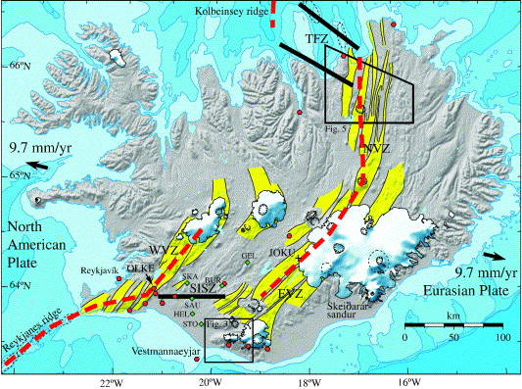Illustration 1: Geophysical processes affecting the Icelandic crust
From a geodetic point of view: If we could resolve the situation in Iceland with its complexity, we could also handle the situation in Scandinavia. On the other hand, it is a small sparsely populated country with limited GIS systems and hence the practical implementation of a dynamic reference frame might be easier.

It is also worth to notice that Iceland is introducing a new reference frame this year, ISN2016. This is a semi-dynamic reference frame with reference epoch 2016.5. This frame is an excellent starting point for a new dynamic reference frame. For more information on geodesy and spatial infrastructure in Iceland, see A2 and A3.

Due to the complexity of the scope of a DRF, it is proposed to set up a long-term NKG activity during the next 4-year period 2018-2022, aiming to investigate and solve necessary issues for the full introduction of a DRF in Iceland. The DRF-Iceland-S1 project described here will focus on some of the basic geodetic concepts needed for a DRF.

The project is divided in four work packages (WP). WP1 will focus on the realization of the DRF in an island where everything is moving and no points can be assumed stable over time. WP2 looks at the user perspective and how users can have easy, efficient and accurate access to positions in the DRF, e.g. through RTK-services or PPP. WP3 will study the deformation models needed to compare and compile coordinates from different epochs. The project will also prepare for the long-term NKG activity in WP4.

Goals

Effect goals
NKG has the necessary competence and experience with reference frames, deformation models and GIS systems to handle future requirements for a reference frame for most practical and geodetic purposes. NKG has a long-term activity on DRF aiming for implementation of a DRF in Iceland.

Outcome/Project goals
The DRF-Iceland-S1 project will develop the basic geodetic concepts for a DRF in Iceland, i.e. the realization of the reference frame, the dissemination of the reference frame and a deformation model to compile coordinates in a test area. The project will also set up a plan for a long-term NKG activity for implementation of a DRF in Iceland.

Consequences of not implementing

The geophysical setting in Iceland makes classical static reference frames difficult to maintain, and over time they will deteriorate leaving an inaccurate reference frame that is not suitable for high precision land surveying. As a consequence, new static reference frames has to be introduced regularly in Iceland. This is a considerable disadvantage to both land surveyors and users of geospatial data, as well as very costly for the local mapping authority.

By not implementing the dynamic reference frame in Iceland status quo is upheld and the known disadvantages of using a static reference frame will continue.

Consequences for users

Implementation of a dynamic reference frame in Iceland marks a paradigm shift. In a dynamic reference frame coordinates of fixed points on the earth vary over time. This has many consequences for land surveyors and other users of geospatial data and they will have to adapt to this new situation. The payoff for the users is that they can do surveying with higher precision over longer time periods.

Note that both the consequences described in this section and in section 1.3 concern the implementation of a fully dynamic reference frame in Iceland (DRF-Iceland). The project DRF-Iceland-S1 will not affect anyone outside the NKG community.

Solution description

In a DRF, a location is described with four parameters: three parameters for the three-dimensional global position and one parameter for the time stamp of the observation (see e.g. A1 for details). With such a description, the co-ordinate of a fixed location will vary with time and hence a way to compare and compile coordinates with different reference epoch is necessary. The basis for a DRF will be the Continuous Operating Reference Stations (CORS) and their positions in a global terrestrial reference frame, e.g. ITRF2014. A DRF for practical purposes presupposes:

- A sufficiently dense active geodetic infrastructure of GNSS stations (CORS) with known coordinates in a global reference frame (ITRF).
- A way to distribute the reference frame to the users, e.g. positioning services.
- Transformations and/or deformation models with sufficient accuracy to meet the future demands for comparison and compiling coordinates from different epochs.
- Geodetic data archive able to store and handle dynamic coordinates.
- GIS systems that are able to handle dynamic coordinates in general and in particular the time dimension of a dynamic reference frame and the various transformations needed.
- Training and education of surveyors.
- Training and education of GIS users.
- Willingness of the users to take such a system into use.

Preconditions 1) to 8) have to be in place to have a well working DRF in the future. However, these points are large and demanding and rely on the international development. E.g. 5) will require large development resources. However, with the announcement of the coming Australian dynamic reference frame it is expected that most GIS software vendors will be working on implementing the updated standards and improving their transformation tools. The time frame for this is unknown, however (see A4 for more details about DRF in GIS systems). Points 6) to 8) are on the user perspective. Training and conviction of the users are a key element for the success of the DRF, but less important at the current stage. Points 1) to 4) are geodetic and a basic common NKG understanding of these are mandatory for the future development.

The work with a DRF in Iceland will therefore be divided in a long-term NKG activity and several short-term NKG projects with clear deliverables. The first project DRF-Iceland-S1 will last until the next NKG General Assembly in fall 2018, and will focus on the main geodetic issues 1), 2) and 3) as well as an overall plan for the long term NKG-activity. Details about the milestones and activity regarding 1) - 3) can be found in Section 2.
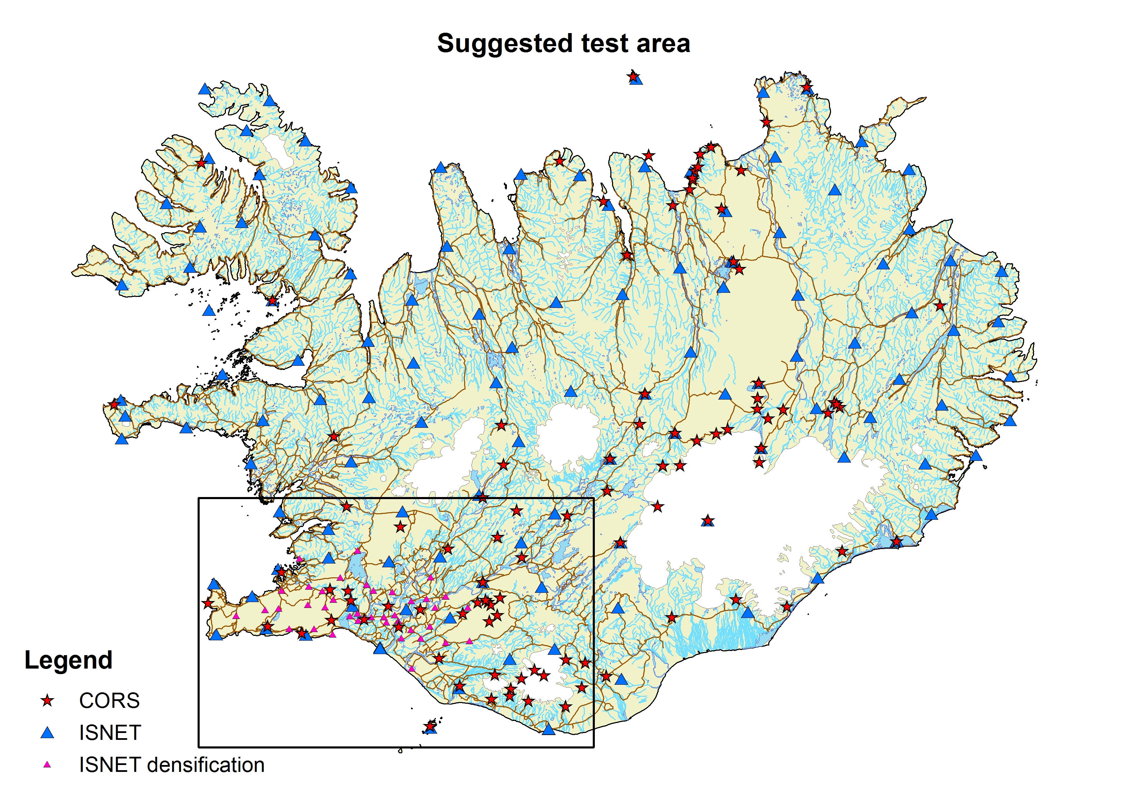Illustration 2: Test area

The geodetic infrastructure in Iceland is varying and more developed in the Southwestern parts of the country (see A2 and Illustration 1). Some of the deliverables depend on a good infrastructure. In these cases, the project will focus on the test area shown in Illustration 2. This area has a sufficiently dense network of CORS to maintain a DRF. Furthermore, the area is affected by several geophysical processes affecting the crust. It lies on two continental plates with associated deformation zones. Earthquakes and volcanic eruptions are expected to occur frequently. Melting glaciers are causing varying uplift and geothermal power plants are causing subsidence of the earth crust. Approximately 80% of the population lives in this area.

Stakeholders

Stakeholder | Contribution, expectations and interest in the project
Landmælingar Íslands | The Icelandic land survey is the primary recipient of the results from the project
NKG | The various agencies under NKG will supply personnel
Icelandic land surveyors | Land surveyors will be affected by the project once the DRF is implemented

Project implementation

Scope and deliverables

Work package | Date | Deliverable  Document (D), Service (S), Results (R)
WP1: Realization of DRF-Iceland | 2017-11 | D1.1: Specification of the GNSS analysis strategy and reference frame realization for the DRF-Iceland (D)
 | 2018-05 | D1.2: Set up an operational GNSS analysis of Icelandic CORS (S)
 | 2017-11 | D1.3: Determine a preliminary secular velocity field for the Icelandic GNSS stations (R)
 | 2018-06 | D1.4: Time-series analysis for determination of velocities and deformations of Icelandic GNSS stations (D/R)
WP2: Access to DRF  (user perspective) | 2017-10 | D2.1: Review of the RTK software options with respect to the requirements of dynamic coordinates in a DRF(D)
 | 2018-06 | D2.2: Implementing a test-RTK service delivering DRF coordinates (D/S)
 | 2018-05 | D2.3: Review of the quality of global PPP for positioning (D)
WP3: Deformation model | 2018-02 | D3.1: Description of concept for deformation model (D)
 | 2018-02 | D3.2: Description of concepts for handling secular motions and deformation events (D)
 | 2018-06 | D3.3: Determination of a preliminary deformation model (R)
 | 2018-03 | D3.4: Description of how to implement deformation model in GIS systems (D)
WP4: Plan for a long term NKG-activity | NKG-GA-2018 | D4: Document describing the plan for the NKG-activity 2018-2022 (D)

All deadlines for the deliverables were set with the expectation that the project DRF-Iceland-S1 begins in September-October 2017.

WP1: Realization of DRF-Iceland

D1.1 Specification of the GNSS analysis strategy and reference frame realization for the DRF-Iceland
In this project, DRF is a reference frame aligned to the latest version of the International Terrestrial Reference Frame (ITRF), currently ITRF2014. The ITRFs are maintained by the International Earth Rotation and Reference Systems Service (IERS) and are based on a global network of geodetic stations. Realization of the DRF-Iceland presupposes a determination of ITRF coordinates at Icelandic CORS stations together with continuous cumulative updates (solutions). The deliverable D1.1 specifies how the DRF-Iceland should be realized and maintained.

D1.2 Set up an operational GNSS analysis of Icelandic CORS
The NKG has an NKG GNSS analysis center (NKG AC) that is a collaboration project aiming at coordinated GNSS processing and analysis of the CORS stations in the Nordic-Baltic area resulting in coordinates and velocities for the stations. The NKG AC follows the guidelines of the EUREF Permanent GNSS Network (EPN) and is therefore consistent with the pan-European EPN solutions. The main idea of the NKG AC is to have distributed GNSS processing and analysis and consequently it has eight local analysis centers (one from each Nordic/Baltic country) and two combination centers. Currently, the NKG AC produces operational GNSS solutions with approximately two weeks delay after the needed products are available.

Iceland is one of the local analysis centers and therefore the existing NKG AC service can be utilized for realizing and maintaining the DRF-Iceland. However, some additional stations west of Iceland should be included to get a good realization of the reference frame. The aim of D1.2 is to set up operational analysis based on the NKG AC following the strategy in D1.1.

D1.3 Determine a preliminary secular velocity field for Icelandic GNSS stations
A deformation model is needed as a part of the maintenance of the DRF-Iceland, compiling different data sets in the DRF-Iceland as well as for linking it to the other Icelandic datums. A model can be derived from coordinate changes or velocities from GNSS stations.

In Iceland, there are currently available preliminary GNSS time series for 20 CORS stations from the NKG AC, as well as results from three nationwide GPS campaigns that are the basis for the latest Icelandic geodetic datums. Delivery D1.3 produces the first estimate for a secular velocity field using these data. This velocity field will be used in D3.3 as a test data set.

D1.4 Time-series analysis for determination of velocities and deformations of Icelandic GNSS stations
Iceland suffers from many different tectonic processes with different behaviors, see A2. A secular velocity field is excluding abrupt coordinate changes from e.g. earthquakes and non-linear movements due to e.g. post-seismic deformations, volcanic eruptions or melting of glaciers. Consequently, a secular model is only an approximate of the deformations.

A more realistic description of movements, reflecting the true crustal deformations, is needed to maintain a DRF over time. In D1.4, we will investigate ways of analyzing and estimating these motions from the time series of CORS and other GNSS stations.

WP2: Access to DRF (user perspective)

High accurate (sub-dm) access to the reference frames is today normally through precise point positioning (PPP) or RTK-services. With PPP, the user has direct access to the global reference frame through GNSS satellites’ accurate orbits and clocks. The PPP does not require any additional (national) reference frame densifications, but PPP is at the moment not at the level needed for the most accurate applications. For these applications, the user access to the reference frame is still through positioning services that rely on a (dense) network of active and permanent CORS, so called (network-) RTK-service. Note that positioning for large user segments e.g. with cell phones, are currently at meter level and therefore out of the scope of this project.

D2.1 Review of the RTK software options with respect to the requirements of dynamic coordinates in a DRF
To access the DRF from an RTK-service, the reference stations need to have accurate coordinates in ITRF2014 at current epoch. These coordinates will be available from the WP1 and are continuously changing (dynamic). Consequently, the RTK-software has to handle regularly updates of the coordinates of the CORS. In Iceland GNSMART software is used in the network-RTK service and D2.1 will review the GNSMART options with respect to the requirements of the DRF-Iceland.

D2.2 Implementing a test-RTK service delivering DRF coordinates
With the findings in D2.1, the aim of D2.2 is to set up a test RTK-service delivering coordinates directly in the DRF-Iceland. This will be running parallel with the existing service and thus includes all necessary software installations, setting up the service and test measurements to verify the operation of a “dynamic” RTK-service.

D2.3 Review of the quality of global PPP for positioning
Even if PPP is not currently fulfilling needs that are required for the most accurate georeferencing, it has potential in the future keeping in mind the major upgrades in GNSS systems and rapid development in instrument and algorithm technology. Today, several global PPP services exist and in D2.3 the current possibilities and limitations in these PPP services as well as future expectations will be reviewed.

WP3: Deformation model

D3.1 Description of concept for deformation model
The deformation model concept should describe the deformation in 3D at any location between any two epochs and, hereby, link objects geo-referenced at different epochs at any epoch, current epoch included. The deformations should be reliable within the uncertainties of the associated coordinates. Practically, the deformation information may be provided in a geographical grid covering the area with a sufficiently dense spacing to describe deformations in fault zones. Other representations of the deformations such as a finite-difference mesh may be considered as well.

D3.2 Description of concepts for handling secular motions and deformation events
The deformation model concept should be able to describe deformations due to continental plate motion and GIA. Those deformations are mainly linear and may be described by their respective velocity fields. The model, however, should also be able to describe deformations due to earthquakes, volcanic eruptions, and current changes in the ice sheets and glaciers. Such deformation may occur instantaneously and may have a relaxation time associated with it. Hence, discrete deformations at times of such events need to be considered, perhaps with an additional time dependent term included.

D3.3 Determination of a preliminary deformation model
The first version of the deformation model will be developed using geodetic information about the deformations based on GNSS. Only the linear parts of the deformations will be considered, so the model will consist of grids of velocities in the three directions: North, East, and Up. In addition, information about faults (or fault zones) will have to be included. Such information may have been extracted from geological observation supplemented by earth observation from satellites.

The velocities may be estimated using an optimal estimation technique such as least squares collocation in which spatial correlations are considered and formal error estimates may be derived. It is important, however, that the information about faults can be taken into account. Hence, it is planned to derive the first version of the deformation model using a gridding technique based on a finite-differences mesh and the use of constraints to represent correlations spatially. In practice, the constraints may be adjusted to reflect the presence of faults. The velocity fields are obtained by rigorous matrix inversion and errors may be computed.

D3.4 Description of how to implement deformation model in GIS systems
Once a suitable concept for the deformation model has been found, a viable solution for operationalizing it in GIS applications should be found. This deliverable will include a brief summary of what the state of the art is in terms of implementation of dynamic reference frames in mainstream GIS applications, with a focus on how deformation models are handled. Additionally, it will provide a prototype implementation of the Icelandic deformation model in the PROJ.4 coordinate transformation software. PROJ.4 is the coordinate transformation engine used by most open source GIS applications today. When the deformation model has been implemented in PROJ.4 it will be possible for the developers of applications like QGIS to incorporate the DRF deformation model in their application.

WP4: Plan for a long term NKG-activity

The long-term goal of the NKG-activity will be a fully implemented DRF in Iceland. To achieve this goal the preconditions 1)-8) in Section 1.5 have to be in place. D4 will describe how this activity should be organized, e.g. the interaction between the activity and short-term project, reporting routines, commitment to resources, scope of activity.

Organization
Roles | Navngitt ressurs. Bidrag i prosjektet. Nødvendig kompetanse
Project owner | Per Erik Oppseth, Kartverket
Steering committee (evt.) | The Iceland Director  Per Erik Opseth, Kartverket  +third member from the presidium e.g. M. Lilje/Thorarinn
Project manager | Halfdan Pascal Kierulf, Kartverket
Project participants | Guðmundur Valsson, Landmælingar Íslands  Martin Lidberg, Lantmäteriet  Olav Vestøl, Kartverket  Per Knudsen, DTU  Kristian Evers, SDFE  Pasi Häkkli, MML  Markku Poutanen, MML
Reference group | NKG Presidium

Estimated costs

Deliverable | Type of cost | Cost | Specification/comment
General project costs | Travel |  | Three meetings for the project group is expected.
WP1: Realization of DRF-Iceland | Man month NKG |  | Two weeks for involved participants
 | Travel |  | 1 or 2 meetings between relevant project members
WP2: Access to DRF | Man month NKG |  | Two weeks for involved participants
 | Travel |  | 1 or 2 meetings between relevant project members
 | Extra GNSMART license |  | Covered by Landmælingar Íslands
WP3: Deformation model | Man month NKG |  | Two weeks for involved participants
 | Travel |  | 1 or 2 meetings between relevant project members
WP4: Plan for a long term NKG activity | Man month NKG |  | Two weeks for involved participants
 | Travel |  | No additional for D4
Total cost
(with internal resources)
Total cost
(without internal resources)

Additional information
The situation in Scandinavia differs from Iceland in many ways. Deformations in the area are to a large extent smaller and secular and hence static reference frames (the national different realizations of ETRS89) are sufficient for a large number of applications. It is also worth to note that Inspire Directive 2007/2/EC dictate use of ETRS89. Consequently, a new dynamic reference frame in Scandinavia will live together with the existing reference frames for a long time.

Attachments
  - Dynamic reference frames
A1-dynamic_reference_frames.docx
Definition and explanation of the concept of dynamic reference frame.

  - Geodesy in Iceland
A2-geodesy_in_iceland.docx
An overview of geodesy in Iceland, including infrastructure, deformation processes and reference frames.
  - Spatial data infrastructure in Iceland
A3-spatial_Data_Infrastructure_in_Iceland.docx
A short introduction to spatial data in Iceland.
  - GIS and dynamic reference frames
A4-GIS_and_dynamic_reference_frames.docx
A short introduction to the challenges that arise in GIS with the introduction of dynamic reference frames.

